Azure Load Balancer —
Definition:
Azure Load Balancer (LB) is a Layer-4 (TCP/UDP) load balancer that distributes incoming traffic across Azure Virtual Machines (VMs) within a region.
Azure Load Balancer ek Layer-4 (Transport Layer) service hai jo TCP/UDP traffic ko multiple backend servers (VMs) ke beech distribute karta hai.
Yeh incoming traffic ko balance karta hai taki load ek VM par na aaye — sabhi VM ka proper utilization ho.
Kaise kaam karta hai?
Architecture:
- Client ka request LB ke Frontend IP par aata hai.
- LB ke pass Backend Pool (VMs) ka group hota hai.VNET NEED TO SELECT .-->(NIC OR IP ADDRESS)
- LB Health Probe se VM ki health check karta hai (Alive hai ya nahi).
- Load Balancing Rules ke basis par traffic kisi healthy VM ko forward karta hai.

Types of Azure LB:
LB Type | Use Case | Example
Public Load Balancer | Internet se traffic distribute karna | Web server, API server, RDP/SSH via Public IP
Internal Load Balancer | VNet ke andar private traffic distribute karna | Internal Application, Database Server, App tier

Important Concepts:
- Frontend IP: Load Balancer ka public ya private IP
- Backend Pool: VMs jo traffic receive karengi
- Health Probe: TCP/HTTP ping jo VM ki availability check karta hai
- Load Balancing Rule: Traffic ka rule (protocol, port etc.)

Kab Use Karte Hai Azure LB?
Jab aapko chahiye:
- High Availability
- Scalability
- Application ko multi VM par run karna hai
- Auto-healing environment
- Failover solution chahiye

Real Time Example:
Public LB
Website hosted on 3 VMs → Public LB → Evenly distribute traffic to 3 VMs.
Internal LB
App tier aur DB tier ke beech private communication → Internal LB → Distribute query to backend servers.

Interview Tip:
Hamesha bolna:
"Azure Load Balancer is used for distributing inbound and outbound traffic across multiple healthy virtual machines to ensure high availability and fault tolerance at Layer 4."

Types of Azure LB:
Type | Purpose
Public Load Balancer | Distributes internet traffic to VMs
Internal Load Balancer | Distributes traffic within VNet (Private)

Key Features:
- Layer-4 load balancing (TCP/UDP)
- High Availability & Scalability
- Health Probes to check VM availability
- NAT Rules for VM access (like RDP/SSH)

Load Balancing Rules:
- Distributes traffic based on front-end IP, protocol, port, and backend pool.

Use Cases:
- Internet-facing Applications (Public LB)
- Internal Applications (Internal LB)
- Application HA & Failover
- Load Balancing across Availability Zones
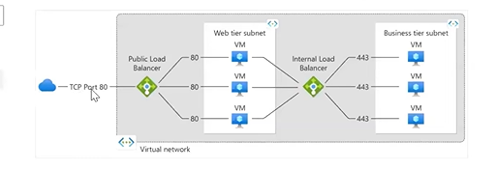
BASIC LB – FREE , STANDARD – CHARGABLE

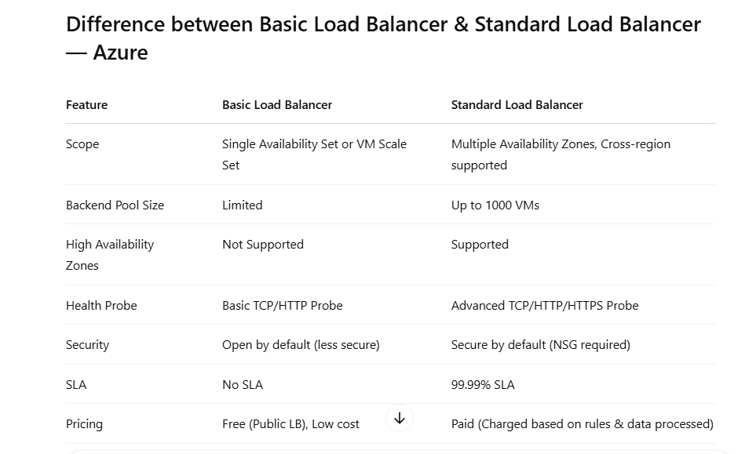
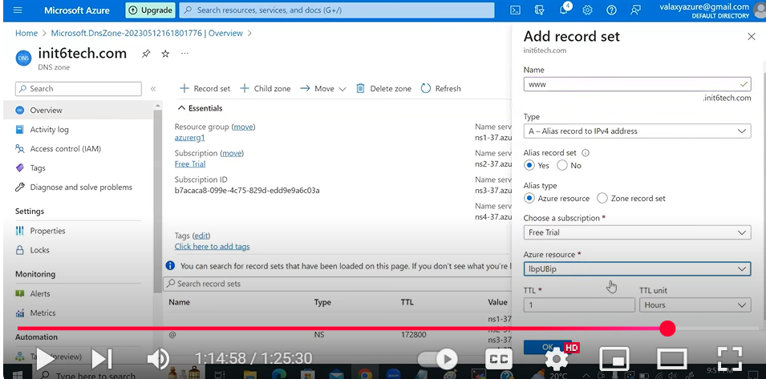

📘 APPLICATION GW –
🔷 1. What is Application Gateway?
- Layer 7 (HTTP/HTTPS) Load Balancer
- Web traffic ko intelligently route karta hai
- URL, Hostname, Headers ke basis par routing karta hai
👉 Unlike L4 LB → ye content-based routing karta hai

🔷 2. Key Features (Most Important)
✅ 1. Web Application Firewall (WAF)
- Protects against OWASP attacks (SQL Injection, XSS)
- Modes:
  - Detection (log only)
  - Prevention (block)

✅ 2. URL-based Routing
Example:
/api → backend1
/images → backend2

✅ 3. Host-based Routing
app1.com → backend1
app2.com → backend2

✅ 4. SSL Termination
- HTTPS decrypt yahi hota hai
- Backend tak HTTP bhej sakte ho

✅ 5. End-to-End SSL
- Client → Gateway → Backend (all HTTPS)

✅ 6. Autoscaling
- Traffic ke basis pe instances increase/decrease

✅ 7. Session Affinity (Sticky Sessions)
- Same user → same backend

✅ 8. Rewrite Rules
- Headers modify kar sakte ho
- URL rewrite possible
Application Gateway Rewrite = "Courier Boy जो Parcel पे Address बदल देता है" 📦
🔹 Azure Application Gateway with Rewrite kya hai
Azure Application Gateway ek Layer-7 load balancer + WAF hai.
Rewrite feature se aap HTTP request/response ko modify kar sakte ho (URL, headers, cookies).

🔹 Kya rewrite kar sakte ho
- URL path change (/old → /new)
- Headers add/remove (X-Forwarded-For)
- Hostname rewrite
- Response headers modify
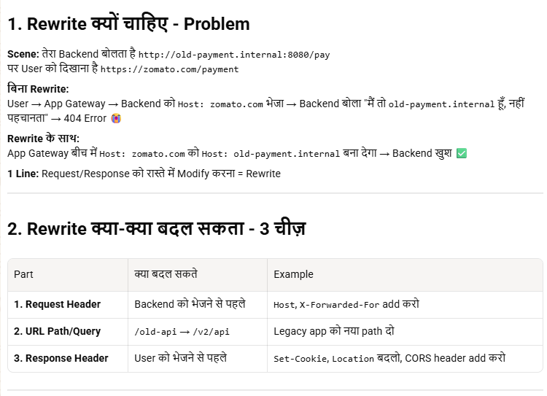
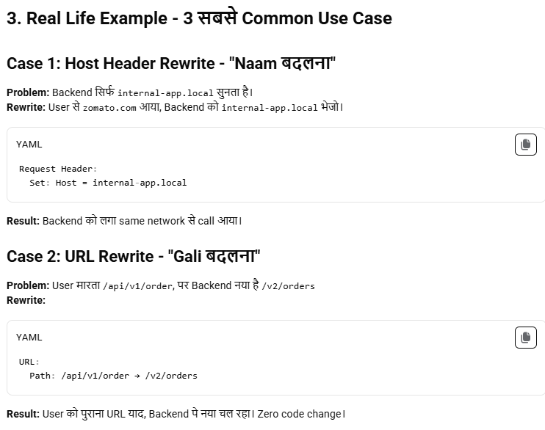
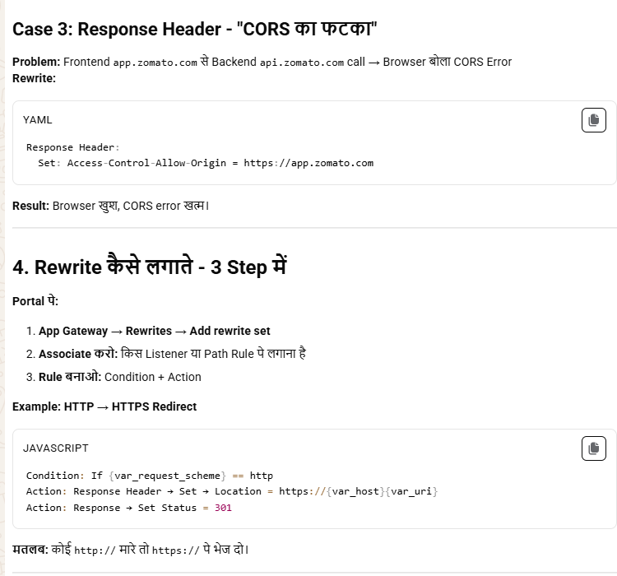
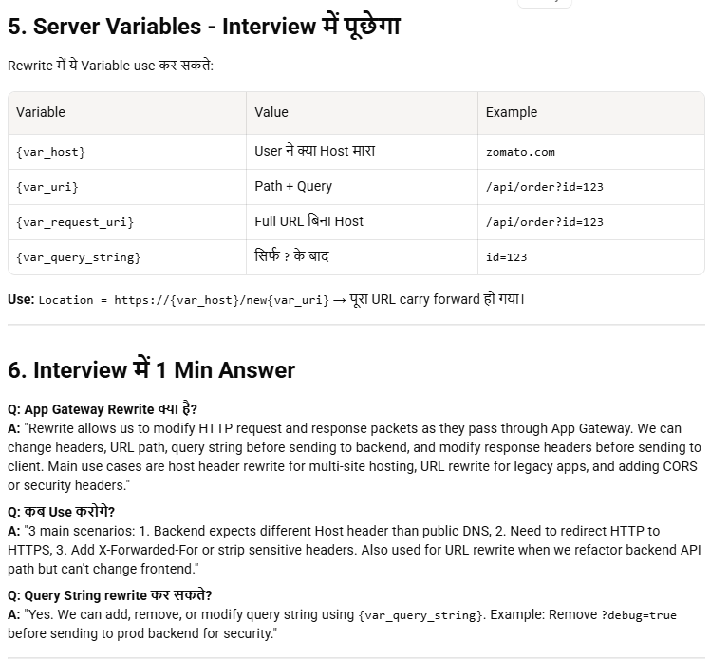
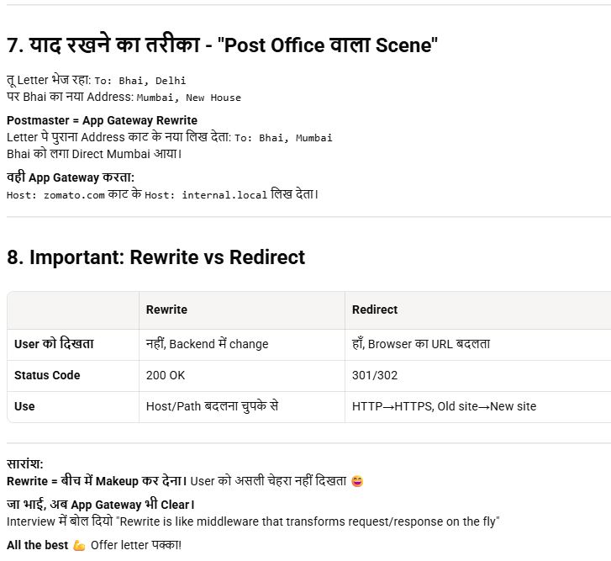

✅ 9. Custom Health Probes
- Backend healthy hai ya nahi check karta hai

🔷 3. Components (Architecture)
1. Frontend IP
- Public / Private IP
2. Listener
- Port + Protocol define karta hai (HTTP/HTTPS)
3. Backend Pool
- VMs / VMSS / AKS / IPs
4. Backend Settings
- Port, protocol, cookie affinity etc.
5. Routing Rules
- Kaunsa request kahan jayega

🔷 4. Request Flow (Step-by-step)
- User request aati hai (HTTP/HTTPS)
- Listener catch karta hai
- Rule match hota hai
- Backend pool select hota hai
- Health check pass hona chahiye
- Request backend ko forward hoti hai

🔷 5. SKU Types (Important)
🔹 v1 (Old)
- Manual scaling
- Basic features
🔹 v2 (Recommended)
- Autoscaling
- Zone redundancy
- Better performance
👉 Always use WAF_v2

🔷 6. Application Gateway vs Load Balancer
Feature | App Gateway | Load Balancer
Layer | L7 | L4
Routing | URL-based | IP-based
WAF | Yes | No
SSL Offload | Yes | No

🔷 7. Application Gateway vs Front Door
Feature | App Gateway | Azure Front Door
Scope | Regional | Global
Use case | Internal apps | Global apps/CDN
Latency | Region-based | Anycast (low latency)

🔷 8. Application Gateway with AKS (Very Important 🔥)
Use case:
- Ingress Controller
👉 Component:
- AGIC (Application Gateway Ingress Controller)
Flow:
User → App Gateway → AKS Pods
Benefits:
- Native Azure integration
- No need for Nginx ingress

🔷 9. WAF Deep Understanding
Based on:
- OWASP Top 10
Protects from:
- SQL Injection
- XSS
- CSRF
Modes:
- Detection → only logs
- Prevention → blocks request

🔷 10. Health Probes
- Default: / path check
- Custom: apni API define kar sakte ho
Example:
/health
/status

🔷 11. Autoscaling Logic
- Min instances: 0/1
- Max instances: 125 (v2)

🔷 12. SSL Certificates
- Upload PFX
- Use Key Vault integration
👉 Best Practice:
- Store certs in Azure Key Vault

🔷 13. Rewrite Use Case
Example:
- Add security headers
- Redirect HTTP → HTTPS

🔷 14. Real-world Architecture Example
User
↓
Application Gateway (WAF enabled)
↓
Backend Pool:
- VMSS / AKS / App Service

🔷 15. When to Use (Important Interview)
Use when:
- Web apps (HTTP/HTTPS)
- Need WAF security
- Need URL routing
- Need SSL termination

🔷 16. When NOT to Use
- Non-HTTP traffic → use Load Balancer
- Global routing → use Front Door

🔷 17. Pricing Factors
- Instances
- Data processed
- WAF rules

🔷 18. Common Interview Questions 🔥
👉 Q1: App Gateway ka layer kya hai?
→ L7
👉 Q2: WAF kya karta hai?
→ OWASP protection
👉 Q3: AKS me kaise use karte ho?
→ AGIC
👉 Q4: SSL termination kya hai?
→ Gateway pe SSL decrypt

🔷 19. Pro Tips (Real DevOps)
- Always use WAF_v2
- Enable autoscaling
- Use Key Vault for certs
- Use custom health probes
- Logs → Azure Monitor
🔷 1. Custom WAF Policy kya hoti hai?
- Default OWASP rules ke alawa apne rules create karte ho
- Allow / Block / Log based on conditions

🔷 2. Types of Custom Rules
✅ 1. Match Rule (Most used)
- Request ko match karke action lo
✅ 2. Rate Limit Rule
- X requests/sec cross → block

🔷 3. Rule Structure (Important)
Har custom rule me 4 cheeze hoti hain:
- Name + Priority
- Match Conditions
- Operator
- Action (Allow / Block / Log)

🔷 4. Example 1 (IP Block)
👉 특정 IP block karna
- Match:
  - Variable: RemoteAddr
  - Operator: IP Match
  - Value: 192.168.1.10
- Action: Block

🔷 5. Example 2 (Country Block)
👉 Geo filtering
- Variable: RemoteAddr
- Operator: GeoMatch
- Value: CN, RU
- Action: Block

🔷 6. Example 3 (Header Based)
👉 Suspicious header block
- Variable: RequestHeaders
- Header: User-Agent
- Operator: Contains
- Value: curl
- Action: Block
🔷 METHOD 1: Azure Portal (Most common)
✅ Step 1: WAF Policy create/open
- Azure Portal → Application Gateway
- Left side → Web Application Firewall
- Open existing OR create new policy

✅ Step 2: Custom Rules section
- Click → Custom rules
- Click → + Add custom rule

✅ Step 3: Basic Details fill karo
- Rule Name: BlockBadIP
- Priority: 1 (IMPORTANT 🔥)
- Rule Type:
  - Match rule OR Rate limit

✅ Step 4: Match Condition define karo
Click Add condition:
Example (IP block):
- Match variable → RemoteAddr
- Operator → IP Match
- Value → 192.168.1.10

✅ Step 5: Action choose karo
- Allow
- Block
- Log
👉 Normally: Block

✅ Step 6: Save karo
- Click Add → Save policy

✅ Step 7: Attach policy
- Go back to Application Gateway
- Attach this WAF policy

📘 Azure Front Door –
🔹 1. Introduction
Azure Front Door ek global, layer-7 (HTTP/HTTPS) load balancer + CDN + WAF service hai.
👉 Yeh users ko nearest edge location se connect karta hai for low latency + high performance

🔹 2. Key Features
- Global load balancing 🌍
- SSL termination
- Path-based routing
- Web Application Firewall (WAF)
- CDN capabilities (caching)
- Automatic failover

🔹 3. How It Works (Flow) 🔥
User Request → Nearest Edge POP → Front Door → Backend (App/VM/API)
👉 Microsoft backbone network use hota hai (fast + secure)

🔹 4. Core Components
🔹 1. Frontend Host
- Public URL (example: app.azurefd.net)

🔹 2. Backend Pool
- Backend resources ka group
- Example: App Service, VM, AKS
👉 Azure Kubernetes Service bhi backend ho sakta hai

🔹 3. Routing Rules
- Decide karta hai request kaha jayegi
- Path-based routing possible
👉 Example:
- /api → backend1
- /web → backend2

🔹 4. Health Probes
- Backend health check karta hai
- Unhealthy backend ko traffic nahi deta

🔹 5. Load Balancing Types
- Latency-based routing (nearest region)
- Priority-based failover
- Weighted routing

🔹 6. Security Features 🔐
- HTTPS (SSL termination)
- Web Application Firewall (WAF)
- DDoS protection (Azure integrated)
- Custom rules (block IP, rate limit)

🔹 7. Caching (CDN Feature)
- Static content cache karta hai edge pe
- Faster response time
👉 Example: images, CSS, JS

🔹 8. Use Cases
- Global web applications
- Multi-region apps
- API acceleration
- Disaster recovery (failover)

🔹 9. Front Door vs Other Services 🔥
👉 vs Azure Application Gateway
- Front Door → Global
- App Gateway → Regional

👉 vs Azure Traffic Manager
- Front Door → HTTP/HTTPS routing
- Traffic Manager → DNS-based routing

🔹 10. Performance Benefits
- Low latency (edge locations)
- Fast failover
- Optimized routing

🔹 11. Important Interview Points
- Layer 7 load balancer
- Global service (not region-specific)
- WAF integrated
- Supports path-based routing
- Uses Microsoft global network

🔹 12. Real-Time Scenario
👉 Global e-commerce app
- Users worldwide
- Front Door route karega nearest region me
- Agar region down → auto failover

🔹 13. Common Interview Questions
- Azure Front Door kya hai?
- Front Door vs Traffic Manager
- Front Door vs Application Gateway
- Routing kaise hoti hai?
- WAF ka role kya hai?

🔥 Final Interview Answer
👉 “Azure Front Door is a global layer-7 load balancer that provides intelligent routing, SSL termination, caching, and WAF security to deliver high performance and availability for web applications.”

Azure Traffic Manager —
Definition:
Azure Traffic Manager is a DNS-based global load balancer that distributes user traffic to the most appropriate endpoint based on routing methods.

Key Features:
- DNS-based traffic distribution
- Improves performance & availability
- Routes traffic across Azure regions or external endpoints
- Monitors endpoint health

Routing Methods:
Method | Purpose
Performance | Lowest latency-based routing
Priority | Primary-Secondary (Failover setup)
Weighted | Traffic distribution using weight
Geographic | Region-specific traffic routing
Multivalue | Returns multiple healthy endpoints
Subnet | IP range-based routing

Use Cases:
- Global load balancing
- Multi-region application availability
- Disaster recovery
- Geo-based content delivery

Limitation:
- DNS-based (only provides endpoint IP)
- Actual data traffic does not pass through Traffic Manager
1. Azure Endpoints
- Ye endpoints Azure ke hi resources hote hain.
- Support karta hai:
  - Azure App Services (Web Apps)
  - Azure Cloud Services
  - Azure Virtual Machines (VMs) with public IP addresses
  - Azure Public IP addresses
- Ye endpoints automatically integrate ho jaate hain Traffic Manager ke sath jab aap select karte ho Azure resource.

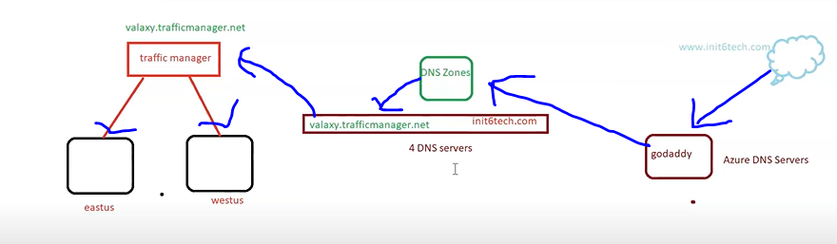

Create a traffic manager
Add endpoints .
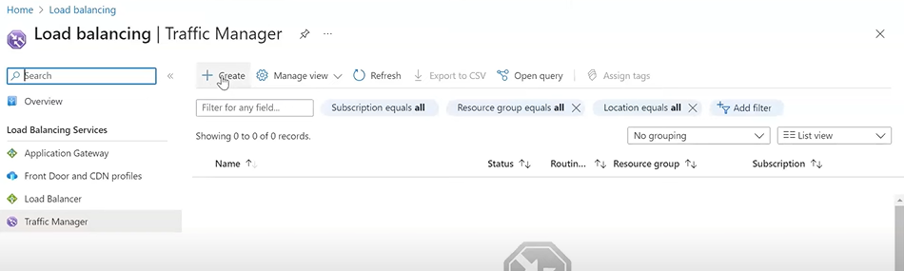
Create two vm in two different region CONFIGURE NGINX IN BOTH . configure DNS NAME FOR BOTH VM .
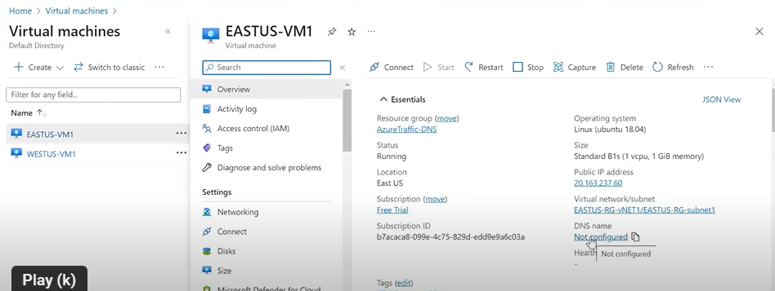
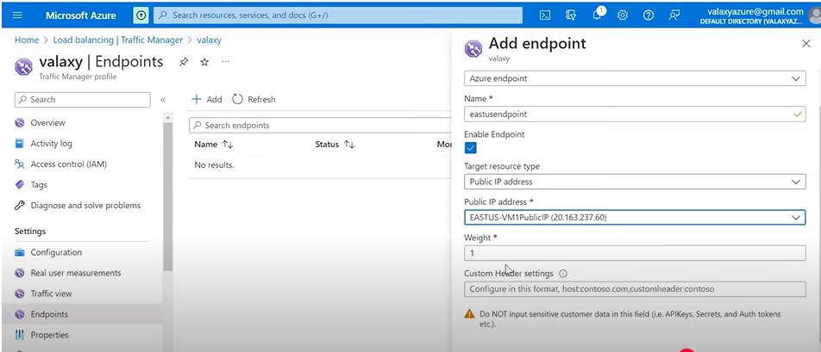
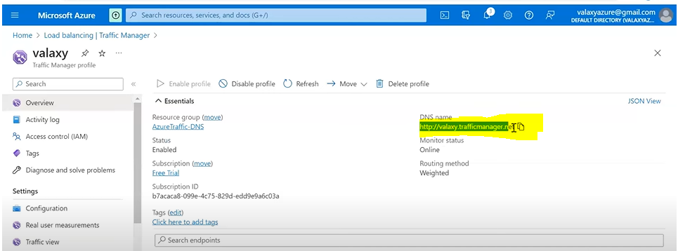
DNS NAME INTO BROWSER AND WE ABLE TO SEE NGINX PAGE.BUT we donot want traffic manger.net in domain we want some good name ,so we buy domain from godaady.
Create DNS zone on azure portal .the purchased domain name from godaddy is used in name section while creating DNS ZONE .
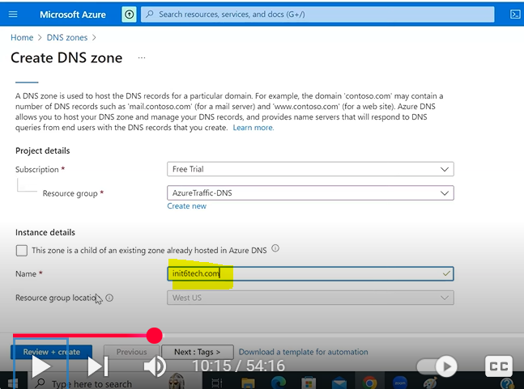
FOUR NS CREATED IN DNS ZONE .

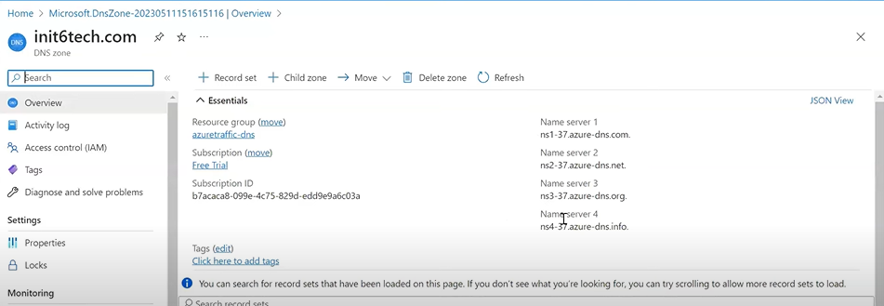
LOGIN GODADDY and update NS with created ns in DNS ZONE .
NOW go in azure DNS and add record with cname.

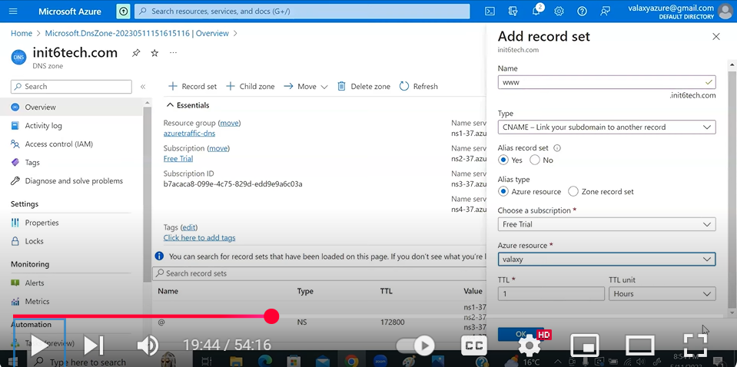

Difference: -
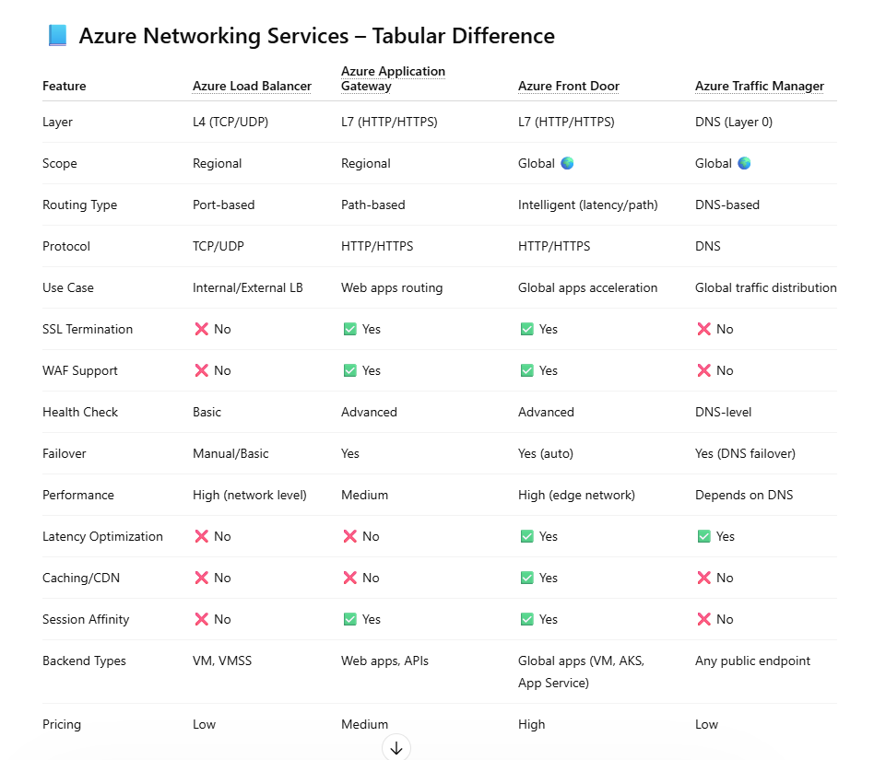
🔥 Quick Summary (Interview बोलने वाला)
👉
- Load Balancer → L4, simple traffic distribution (VM level)
- Application Gateway → L7, web routing + WAF (regional)
- Front Door → Global L7, CDN + WAF + low latency
- Traffic Manager → DNS-based global routing

🔥 One-Line Use Case
- LB → “VM traffic balance karna hai”
- App GW → “Web app + WAF chahiye”
- Front Door → “Global app + performance + security”
- Traffic Manager → “DNS level global routing”

